***GENERATE Reports using Cucumber***

1. *Create a new* ***Folder****, right click on the project ‘****ProjectWin****‘ and select* ***New*** *>* ***Folder***

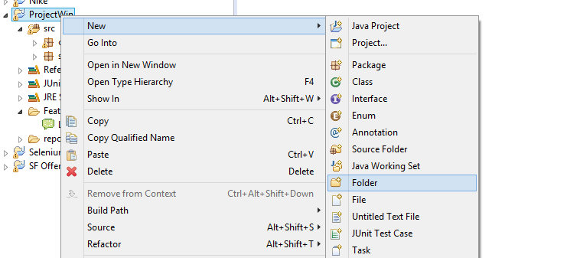

1. *Name it as ‘****reports****’ and click on* ***Finish*** *button*

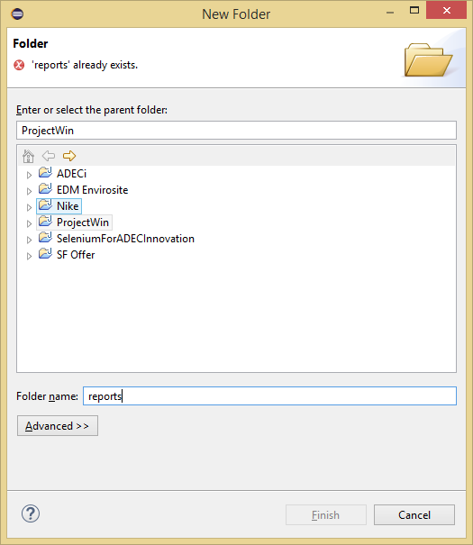

***XML Report***

1. *In* ***TestRunner,*** *use the options when calling your cucumber-jvm :* ***format={“junit:reports/junit/reports.xml”}***

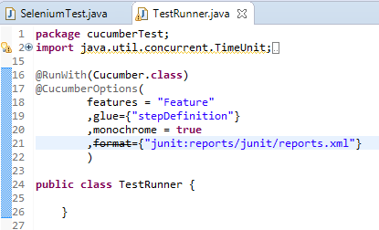

1. *Run* ***TestRunner*** *as* ***JUnit Test***

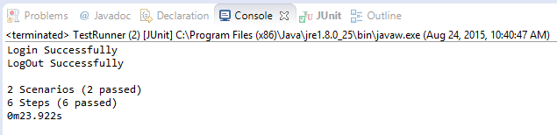

1. *Check* ***Workspace*** *if* ***XML Report*** *is available*

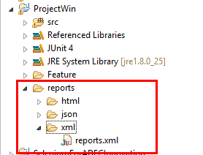

1. *Open* ***reports.xml*** *file*

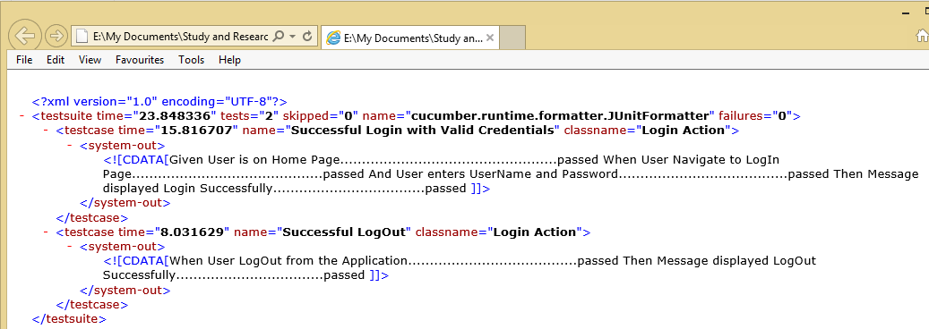

***HTML Report***

1. *In* ***TestRunner,*** *use the options when calling your cucumber-jvm :* ***format={"pretty", "html:reports/html"}***

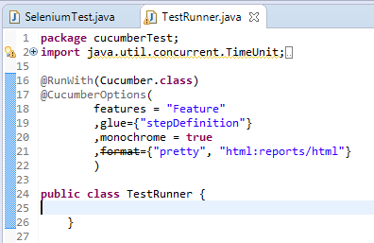

1. *Run* ***TestRunner*** *as* ***JUnit Test***

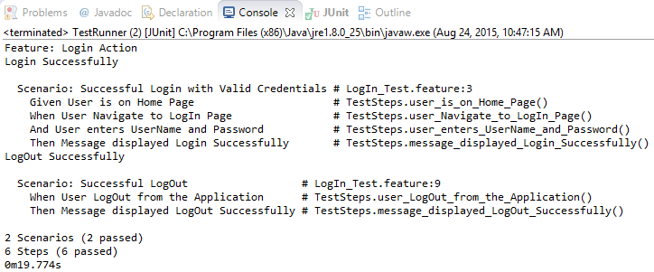

1. *Check* ***Workspace*** *if* ***HTML Report*** *is available*

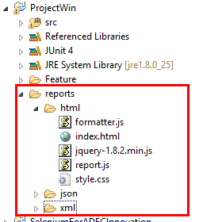

1. *Open* ***index.html*** *file*

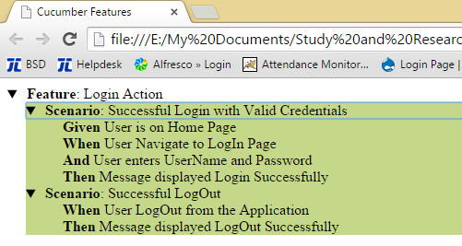

***JSON Report***

1. *In* ***TestRunner,*** *use the options when calling your cucumber-jvm :* ***format={"*** ***json:reports/json/cucumber.json"}***

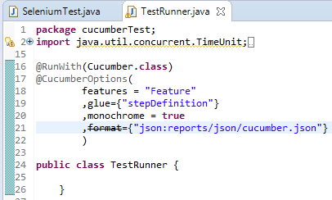

1. *Run* ***TestRunner*** *as* ***JUnit Test***



1. *Check* ***Workspace*** *if* ***JSON Report*** *is available*

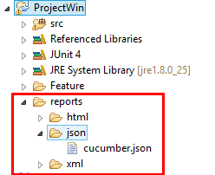

1. *Open* ***reports.json*** *file*

